**Project Design Phase-I**

**Proposed Solution Template**

|  |  |
| --- | --- |
| Date | 15 October 2022 |
| Team ID | PNT2022TMID52614 |
| Project Name | Containment Zone Alerting Application |
| Maximum Marks | 2 Marks |

1.Create a Bucket in IBM object storage.

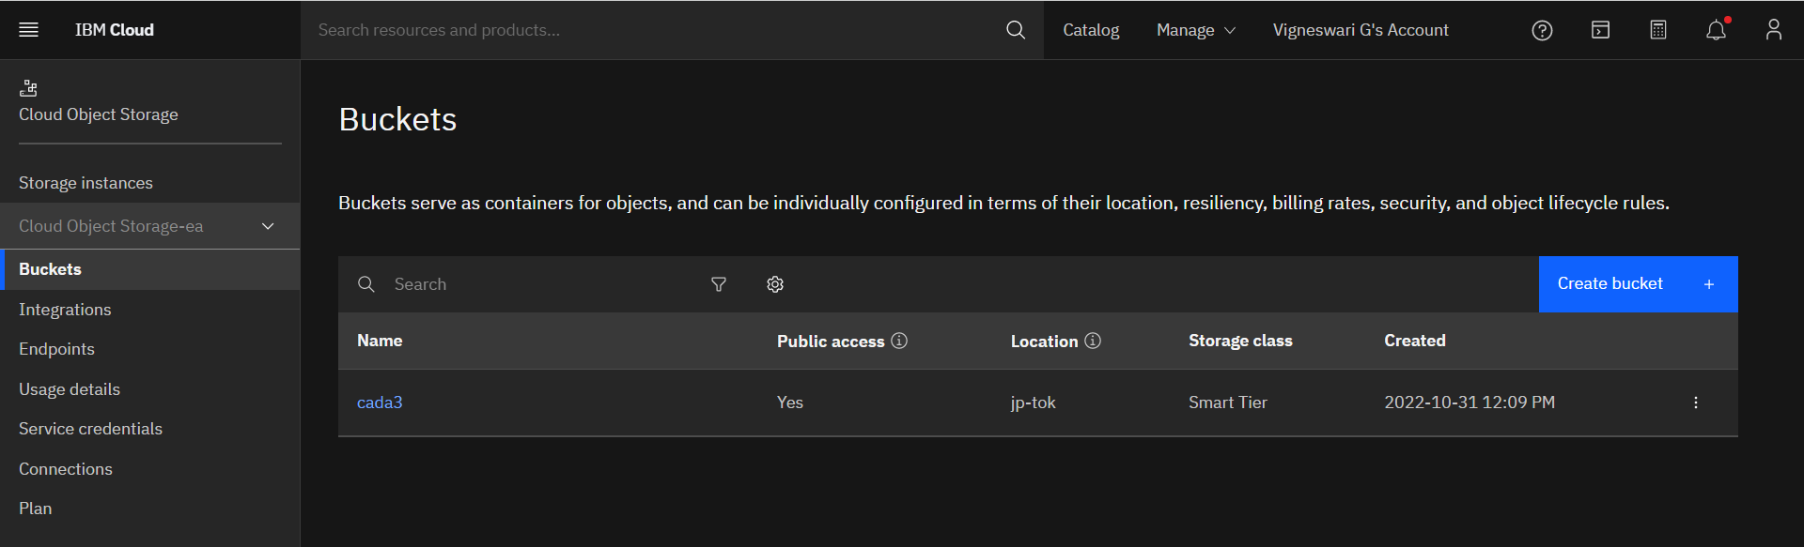

2. Upload any 5 images to IBM object storage and make it public. Write HTML code to displaying all the 5 images.

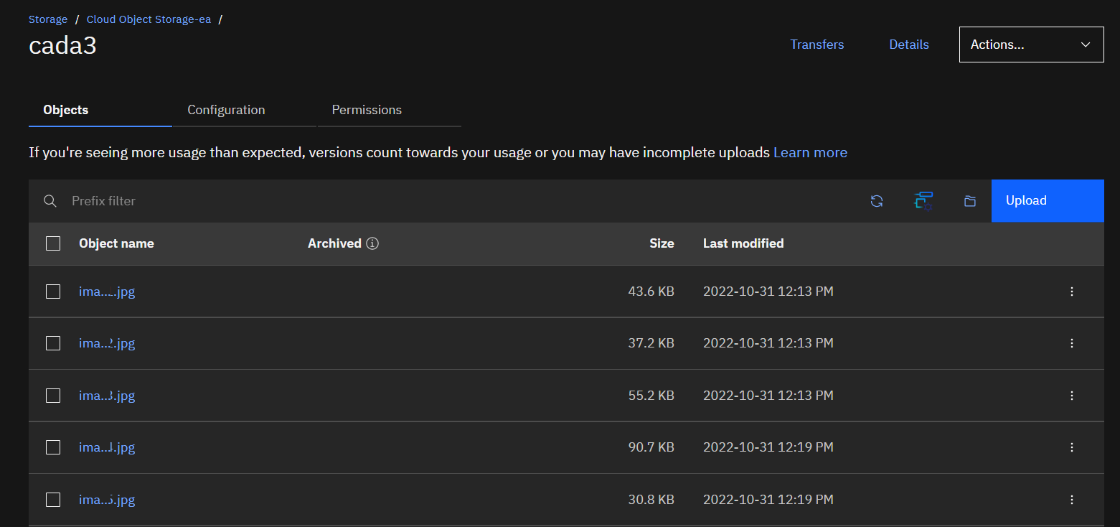

**HTML Code:**

**<!DOCTYPE** *html***>**

<html *lang*="en">

<head>

    <meta *charset*="UTF-8">

    <meta *http-equiv*="X-UA-Compatible" *content*="IE=edge">

    <meta *name*="viewport" *content*="width=device-width, initial-scale=1.0">

    <title>Nature</title>

</head>

<body>

    <h2 *style*="color:red">Most Beautiful Places to Explore...</h2>

    <img *src*="https://cada3.s3.jp-tok.cloud-object-storage.appdomain.cloud/image-2.jpg" *alt*="image-2" *width*="20%" *height*="20%">

    <img *src*="https://cada3.s3.jp-tok.cloud-object-storage.appdomain.cloud/image-3.jpg" *alt*="image-3" *width*="20%" *height*="20%"><br>

    <img *src*="https://cada3.s3.jp-tok.cloud-object-storage.appdomain.cloud/image-1.jpg" *alt*="image-1" *width*="20%" *height*="20%">

    <img *src*="https://cada3.s3.jp-tok.cloud-object-storage.appdomain.cloud/image-4.jpg" *alt*="image-4" *width*="20%" *height*="20%"><br>

    <img *src*="https://cada3.s3.jp-tok.cloud-object-storage.appdomain.cloud/image-5.jpg" *alt*="image-5" *width*="20%" *height*="20%">

</body>

</html>

**OUTPUT:**



3. Upload a CSS page to the object storage and use the same page in your HTML code.

**HTML Code:**

**<!DOCTYPE** *html***>**

<html *lang*="en">

<head>

    <meta *charset*="UTF-8">

    <meta *http-equiv*="X-UA-Compatible" *content*="IE=edge">

    <meta *name*="viewport" *content*="width=device-width, initial-scale=1.0">

    <link *rel*="stylesheet" *href*="https://cada3.s3.jp-tok.cloud-object-storage.appdomain.cloud/styles.css">

    <title>Nature</title>

</head>

<body>

    <h2 >Most Beautiful Places to Explore...</h2>

    <img *src*="https://cada3.s3.jp-tok.cloud-object-storage.appdomain.cloud/image-2.jpg" *alt*="image-2">

    <img *src*="https://cada3.s3.jp-tok.cloud-object-storage.appdomain.cloud/image-3.jpg" *alt*="image-3"><br>

    <img *src*="https://cada3.s3.jp-tok.cloud-object-storage.appdomain.cloud/image-1.jpg" *alt*="image-1">

    <img *src*="https://cada3.s3.jp-tok.cloud-object-storage.appdomain.cloud/image-4.jpg" *alt*="image-4"><br>

    <img *src*="https://cada3.s3.jp-tok.cloud-object-storage.appdomain.cloud/image-5.jpg" *alt*="image-5">

</body>

</html>

CSS File uploaded:

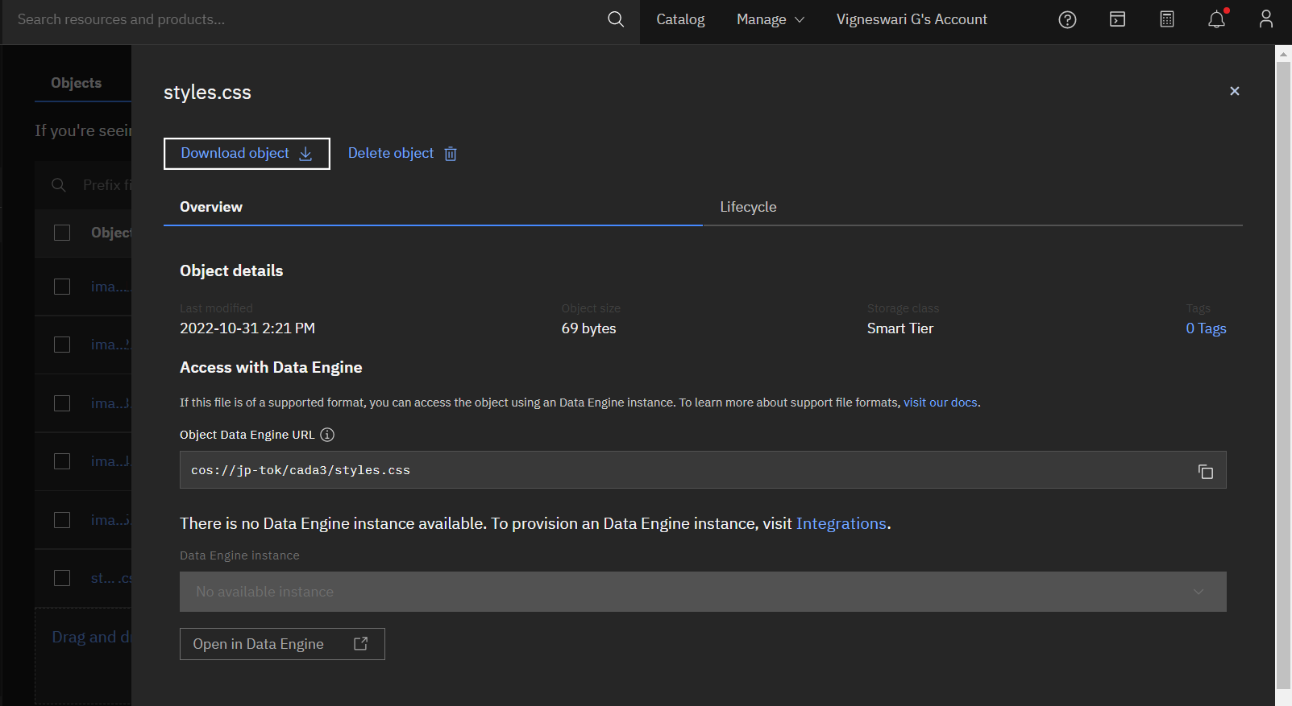

4. Design a chatbot using IBM Watson assistant for hospital. Ex: User comes with query to know the branches for that hospital in your city. Submit the web URL of that chat bot as an assignment.

Web URL of chat box:

<https://web-chat.global.assistant.watson.appdomain.cloud/preview.html?backgroundImageURL=https%3A%2F%2Fau-syd.assistant.watson.cloud.ibm.com%2Fpublic%2Fimages%2Fupx-6a642726-2589-4609-89f8-d7ea7c4bf2b1%3A%3A3fc99d22-1ec4-4920-aa68-15560af0f2d6&integrationID=75511922-07f4-4341-970f-fe3e995f3942&region=au-syd&serviceInstanceID=6a642726-2589-4609-89f8-d7ea7c4bf2b1>

5. Create Watson assistant service with 10 steps and use 3 conditions in it. Load that script in HTML page.

5. Create Watson assistant service with 10 steps and use 3 conditions in it. Load that script in HTML page.

**HTML CODE:**

<!DOCTYPE html>

<html lang="en">

<head>

    <meta charset="UTF-8">

    <meta http-equiv="X-UA-Compatible" content="IE=edge">

    <meta name="viewport" content="width=device-width, initial-scale=1.0">

    <script>

        window.watsonAssistantChatOptions = {

          integrationID: "1b30ea5f-e84e-4ea1-92b4-c73b68b91e30", // The ID of this integration.

          region: "us-south", // The region your integration is hosted in.

          serviceInstanceID: "ca1cfc0c-9550-4f88-bd8c-f5f1cd2ce705", // The ID of your service instance.

          onLoad: function(instance) { instance.render(); }

        };

        setTimeout(function(){

          const t=document.createElement('script');

          t.src="https://web-chat.global.assistant.watson.appdomain.cloud/versions/" + (window.watsonAssistantChatOptions.clientVersion || 'latest') + "/WatsonAssistantChatEntry.js";

          document.head.appendChild(t);

        });

      </script>

    <title>Document</title>

</head>

<body style="background-color: grey;">

    <h2>DADA Assistant</h2>

    <a href="https://web-chat.global.assistant.watson.appdomain.cloud/preview.html?backgroundImageURL=https%3A%2F%2Fau-syd.assistant.watson.cloud.ibm.com%2Fpublic%2Fimages%2Fupx-6a642726-2589-4609-89f8-d7ea7c4bf2b1%3A%3A3fc99d22-1ec4-4920-aa68-15560af0f2d6&integrationID=75511922-07f4-4341-970f-fe3e995f3942&region=au-syd&serviceInstanceID=6a642726-2589-4609-89f8-d7ea7c4bf2b1"></a>

</body>

</html>